2017지방대회 3과제(SC)

Basic configuration

Router(config)#line console 0 //콘솔 암호 설정

Router(config-line)#password cisco

Router(config)#enable password cisco123 //enable암호 설정

Router(config)#line vty 0 4 //telnet 접속 설정

Router(config)#login

Router(config-line)#password 2017skills

Router(config)#ntp server 201.210.12.2 //ntp서버 설정

Switch configuration

switch1)

switch1(config)#vlan 10

switch1(config-vlan)#name packet

switch1(config)#vlan 20

switch1(config-vlan)#name Tracer

switch1(config)#vlan 30

switch1(config-vlan)#name Gold

switch1(config)#vlan 40

switch1(config-vlan)#name Skills

switch1(config)#interface f0/2

switch1(config-if)#switchport mode access

switch1(config-if)#switchport access vlan 10

switch1(config)#interface f0/3

switch1(config-if)#switchport mode access

switch1(config-if)#switchport access vlan 20

switch1(config)#interface f0/4

switch1(config-if)#switchport mode access

switch1(config-if)#switchport access vlan 30

switch1(config)#interface f0/5

switch1(config-if)#switchport mode access

switch1(config-if)#switchport access vlan 40

switch1(config)#interface f0/1

switch1(config-if)#switchport mode trunk

switch3)

switch3(config)#vlan 50

switch3(config-vlan)#name bosspad

switch3(config)#vlan 60

switch3(config-vlan)#name Good

switch3(config)#vlan 70

switch3(config-vlan)#name chrom

switch3(config)#interface f0/3

switch3(config-if)#switchport mode access

switch3(config-if)#switchport access vlan 50

switch3(config)#interface f0/5

switch3(config-if)#switchport mode access

switch3(config-if)#switchport access vlan 60

switch3(config)#interface f0/6

switch3(config-if)#switchport mode access

switch3(config-if)#switchport access vlan 70

switch3(config)#interface f0/1

switch3(config-if)#switchport mode trunk

Inter-VLAN

Router9)

Router9(config)#interface f0/0

Router9(config-if)#no shutdown

Router9(config)#interface f0/0.10

Router9(config-subif)#encapsulation dot1Q 10

Router9(config-subif)#ip address 200.230.23.1 255.255.255.0

Router9(config)#interface f0/0.20

Router9(config-subif)#encapsulation dot1Q 20

Router9(config-subif)#ip address 200.230.24.1 255.255.255.0

Router9(config)#interface f0/0.30

Router9(config-subif)#encapsulation dot1Q 30

Router9(config-subif)#ip address 200.230.25.1 255.255.255.0

Router9(config)#interface f0/0.40

Router9(config-subif)#encapsulation dot1Q 40

Router9(config-subif)#ip address 200.230.26.1 255.255.255.0

Router12)

Router12(config)#interface f0/0

Router12(config-if)#no shutdown

Router12(config)#interface f0/0.50

Router12(config-subif)#encapsulation dot1Q 50

Router12(config-subif)#ip address 200.230.29.1 255.255.255.0

Router12(config)#interface f0/0.60

Router12(config-subif)#encapsulation dot1Q 60

Router12(config-subif)#ip address 200.230.30.1 255.255.255.0

Router12(config)#interface f0/0.70

Router12(config-subif)#encapsulation dot1Q 70

Router12(config-subif)#ip address 200.230.31.1 255.255.255.0

Frame-Relay

Router4)

Router4(config)#interface s0/2/1

Router4(config-if)#encapsulation frame-relay

Router4(config-if)#no shutdown

Router4(config-if)#frame-relay lmi-type cisco

Router4(config-if)#no frame-relay inverse-arp

Router4(config-if)#ip ospf network broadcast

Router4(config-if)#ip ospf priority 0

Router4(config)#interface s0/2/1.1 multipoint

Router4(config-subif)#ip address 200.230.14.1 255.255.255.0

Router4(config-subif)#frame-relay map ip 200.230.14.3 301 broadcast

Router4(config-subif)#frame-relay map ip 200.230.14.2 301 broadcast

Router14)

Router14(config)#interface s0/2/0

Router14(config-if)#encapsulation frame-relay

Router14(config-if)#no shutdown

Router14(config-if)#frame-relay lmi-type cisco

Router14(config-if)#no frame-relay inverse-arp

Router14(config-if)#ip ospf network broadcast

Router14(config-if)#ip ospf priority 255

Router14(config)#interface s0/2/0.1 multipoint

Router14(config-subif)#ip address 200.230.14.2 255.255.255.0

Router14(config-subif)#frame-relay map ip 200.230.14.1 103 broadcast

Router14(config-subif)#frame-relay map ip 200.230.14.3 104 broadcast

Router13)

Router13(config)#interface s0/2/0

Router13(config-if)#encapsulation frame-relay

Router13(config-if)#no shutdown

Router13(config-if)#frame-relay lmi-type cisco

Router13(config-if)#no frame-relay inverse-arp

Router13(config-if)#ip ospf network broadcast

Router13(config-if)#ip ospf priority 0

Router13(config)#interface s0/2/0.1 multipoint

Router13(config-subif)#ip address 200.230.14.3 255.255.255.0

Router13(config-subif)#frame-relay map ip 200.230.14.1 401 broadcast

Router13(config-subif)#frame-relay map ip 200.230.14.2 402 broadcast

Router10)

Router10(config)#interface s0/2/1

Router10(config-if)#encapsulation frame-relay

Router10(config-if)#no shutdown

Router10(config-if)#frame-relay lmi-type cisco

Router10(config-if)#no frame-relay inverse-arp

Router10(config-if)#ip ospf network broadcast

Router10(config-if)#ip ospf priority 0

Router10(config)#interface s0/2/1.1 multipoint

Router10(config-subif)#ip address 200.230.27.1 255.255.255.0

Router10(config-subif)#frame-relay map ip 200.230.27.2 201 broadcast

Router10(config-subif)#frame-relay map ip 200.230.27.3 201 broadcast

Router11)

Router11(config)#interface s0/2/0

Router11(config-if)#encapsulation frame-relay

Router11(config-if)#no shutdown

Router11(config-if)#frame-relay lmi-type cisco

Router11(config-if)#no frame-relay inverse-arp

Router11(config-if)#ip ospf network broadcast

Router11(config-if)#ip ospf priority 255

Router11(config)#interface s0/2/0.1 multipoint

Router11(config-subif)#ip address 200.230.27.2 255.255.255.0

Router11(config-subif)#frame-relay map ip 200.230.27.1 102 broadcast

Router11(config-subif)#frame-relay map ip 200.230.27.3 103 broadcast

Router12)

Router12(config)#interface s0/2/0

Router12(config-if)#encapsulation frame-relay

Router12(config-if)#no shutdown

Router12(config-if)#frame-relay lmi-type cisco

Router12(config-if)#no frame-relay inverse-arp

Router12(config-if)#ip ospf network broadcast

Router12(config-if)#ip ospf priority 0

Router12(config)#interface s0/2/0.1 multipoint

Router12(config-subif)#ip address 200.230.27.3 255.255.255.0

Router12(config-subif)#frame-relay map ip 200.230.27.1 301 broadcast

Router12(config-subif)#frame-relay map ip 200.230.27.2 301 broadcast

FULL ROUTING

Router1)

Router1(config)#router rip

Router1(config-router)#version 2

Router1(config-router)#no auto-summary

Router1(config-router)#network 201.210.7.0

Router1(config-router)#network 201.210.8.0

Router2)

Router2(config)#router rip

Router2(config-router)#version 2

Router2(config-router)#no auto-summary

Router2(config-router)#network 201.210.8.0

Router2(config-router)#network 201.210.9.0

Router2(config-router)#network 201.210.10.0

Router2(config-router)#network 201.210.11.0

Router2(config-router)#network 201.210.13.0

Router3)

Router3(config)#router rip

Router3(config-router)#version 2

Router3(config-router)#no auto-summary

Router3(config-router)#network 201.210.11.0

Router3(config-router)#network 201.210.12.0

Router4)

Router4(config)#router rip

Router4(config-rotuer)#version 2

Router4(config-router)#no auto summary

Router4(config-router)#network 201.210.13.0

Router4(config-router)#redistribute ospf 7 metric 3

Router4(config)#router ospf 7

Router4(config-router)#network 200.230.14.1 0.0.0.0 area 0

Router4(config-router)#redistribute rip subnets

Router5)

Router5(config)#router ospf 7

Router5(config-router)#network 200.230.16.1 0.0.0.0 area 0

Router5(config-router)#network 200.230.17.1 0.0.0.0 area 0

Router6)

Router6(config)#router ospf 7

Router6(config-router)#network 200.230.17.2 0.0.0.0 area 0

Router6(config-router)#network 200.230.18.1 0.0.0.0 area 0

Router6(config-router)#network 200.230.19.1 0.0.0.0 area 0

Router7)

Router7(config)#router ospf 7

Router7(config-router)#network 200.230.18.2 0.0.0.0 area 0

Router7(config-router)#network 200.230.21.1 0.0.0.0 area 0

Router8)

Router8(config)#router ospf 7

Router8(config-router)#network 200.230.20.1 0.0.0.0 area 0

Router8(config-router)#network 200.230.19.2 0.0.0.0 area 0

Router9)

Router9(config)#router ospf 7

Router9(config-router)#network 200.230.21.2 0.0.0.0 area 0

Router9(config-router)#network 200.230.22.1 0.0.0.0 area 0

Router9(config-router)#network 200.230.23.1 0.0.0.0 area 0

Router9(config-router)#network 200.230.24.1 0.0.0.0 area 0

Router9(config-router)#network 200.230.25.1 0.0.0.0 area 0

Router9(config-router)#network 200.230.26.1 0.0.0.0 area 0

Router10)

Router10(config)#router ospf 7

Router10(config-router)#network 200.230.22.2 0.0.0.0 area 0

Router10(config-router)#network 200.230.27.1 0.0.0.0 area 0

Router11)

Router11(config)#router ospf 7

Router11(config-router)#network 200.230.27.2 0.0.0.0 area 0

Router11(config-router)#network 200.230.28.1 0.0.0.0 area 0

Router12)

Router12(config)#router ospf 7

Router12(config-router)#network 200.230.27.3 0.0.0.0 area 0

Router12(config-router)#network 200.230.29.1 0.0.0.0 area 0

Router12(config-router)#network 200.230.30.1 0.0.0.0 area 0

Router12(config-router)#network 200.230.31.1 0.0.0.0 area 0

Router12(config-router)#network 200.230.32.1 0.0.0.0 area 0

Router13)

Router13(config)#router ospf 7

Router13(config-router)#network 200.230.14.3 0.0.0.0 area 0

Router13(config-router)#network 200.230.16.2 0.0.0.0 area 0

Router13(config-router)#network 200.230.33.1 0.0.0.0 area 0

Router14)

Router14(config)#router ospf 7

Router14(config-router)#network 200.230.14.2 0.0.0.0 area 0

Router14(config-router)#network 200.230.15.1 0.0.0.0 area 0

Router15)

Router15(config)#router ospf 7

Router15(config-router)#network 200 230.32.2 0.0.0.0 area 0

Router15(config-router)#network 200.230.34.2 0.0.0.0 area 0

Router15(config-router)#network 200.230.35.1 0.0.0.0 area 0

Web & DNS

Server1)

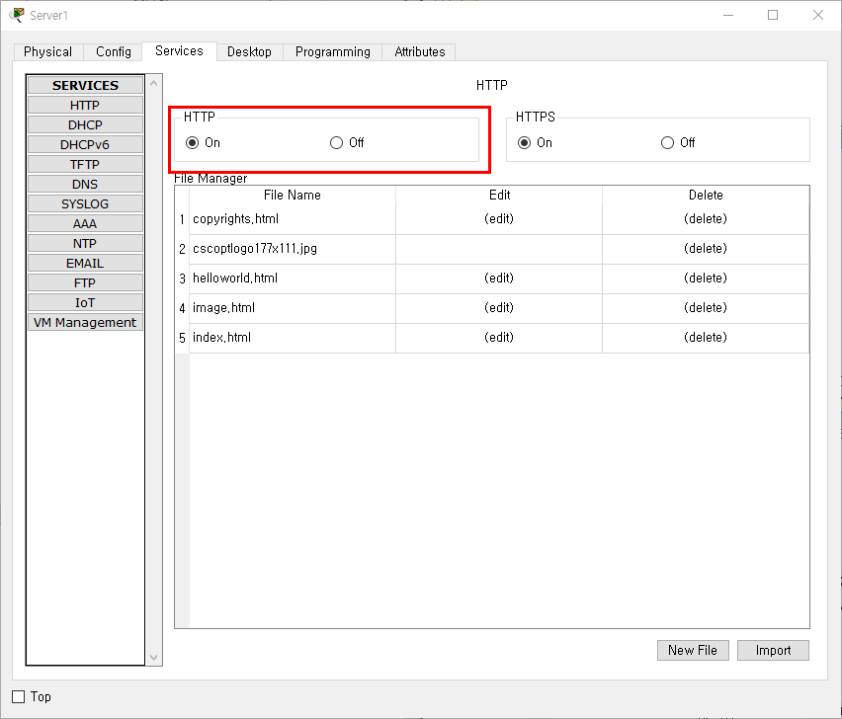

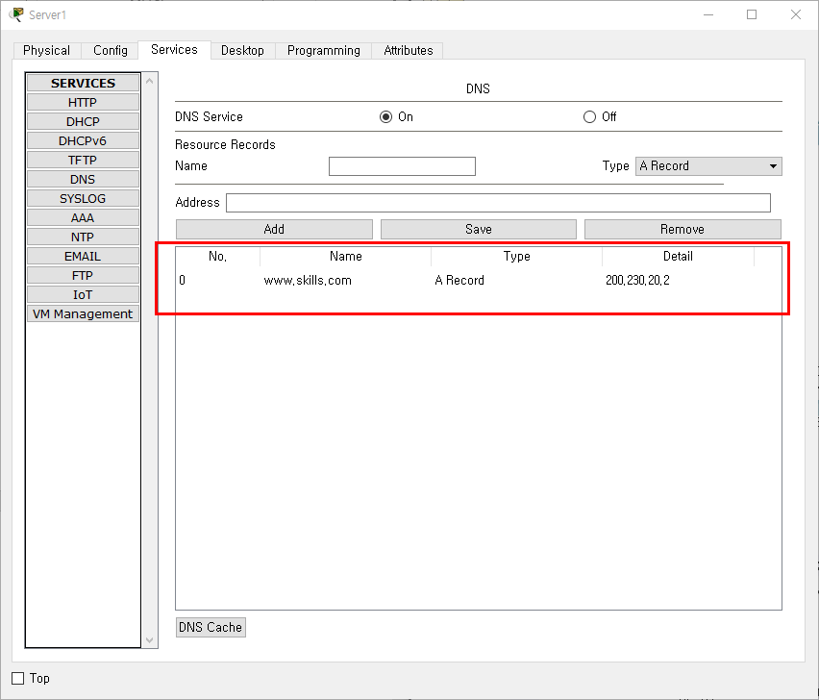

서버설정후 모든 클라이언트들은 DNS서버로 Server1을 등록

Wireless

Authentication Server0

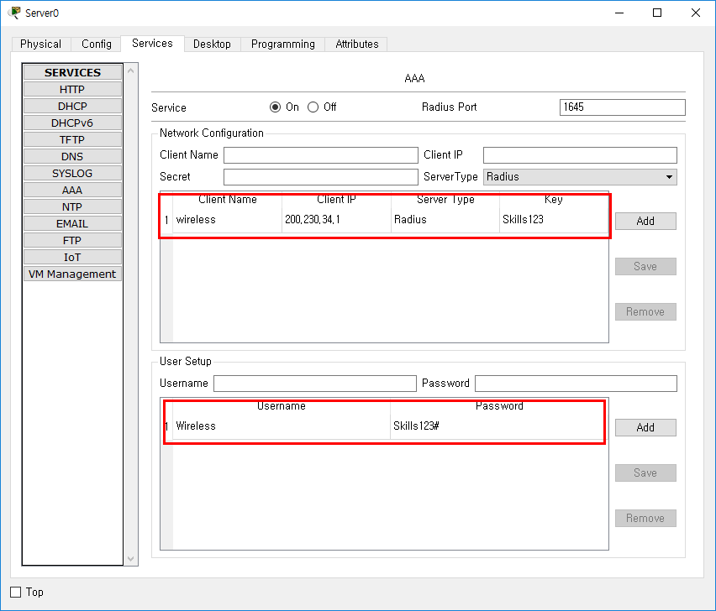

Wireless Router)

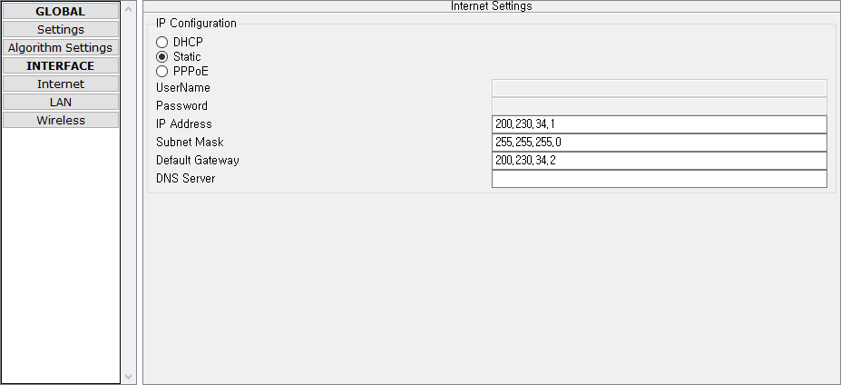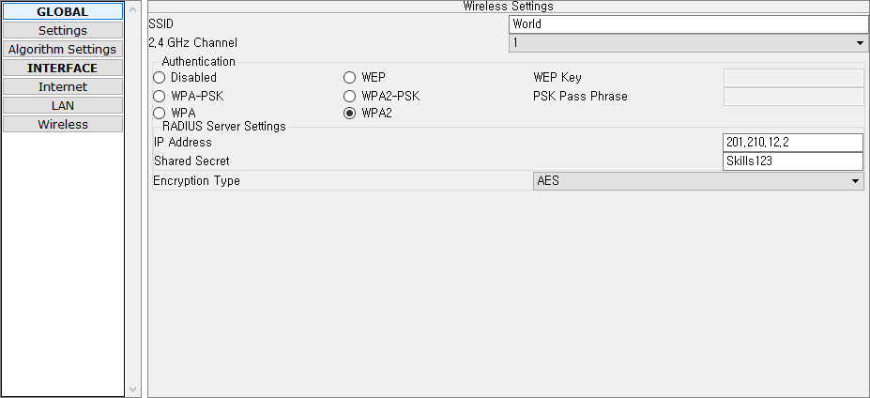

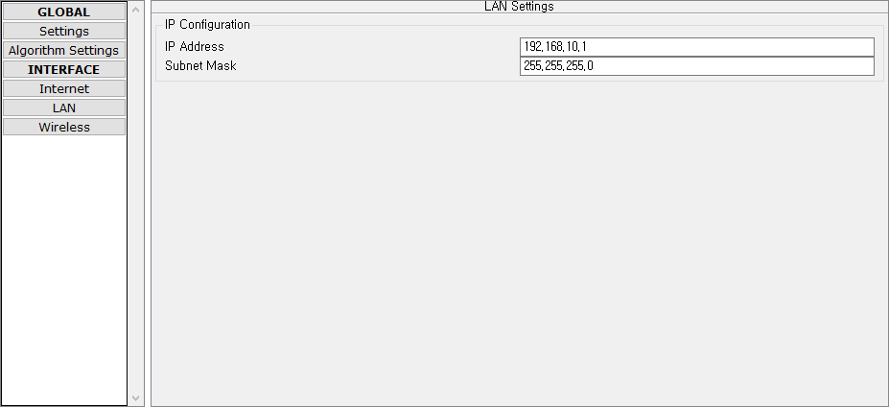

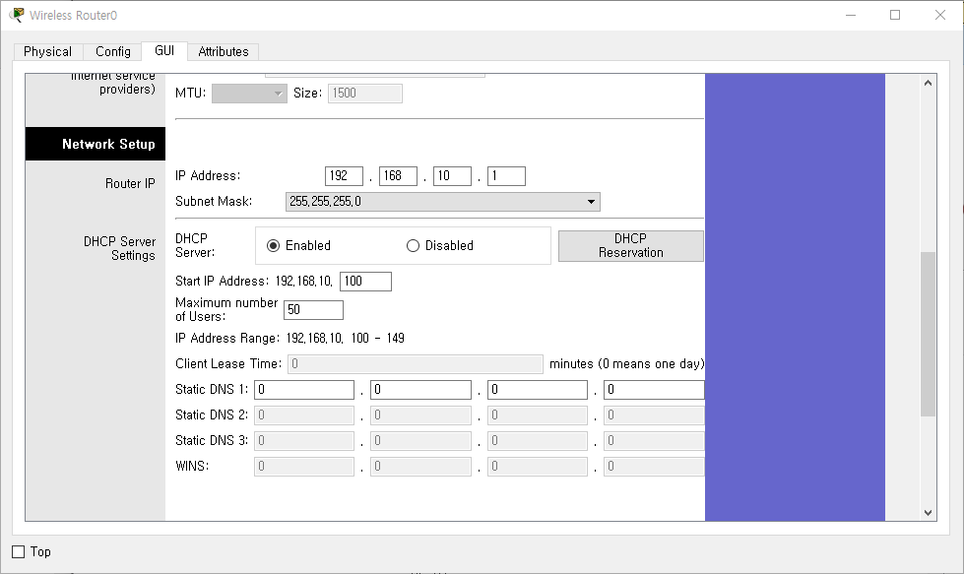

Wireless Client)

